SQL
Session-7
1.Create a table called Restaurant with columns: id, name, location, and cuisine. Apply NOT NULL constraint to name and location, and make id the PRIMARY KEY.
CREATE TABLE Restaurant(Id INT PRIMARY KEY AUTO_INCREMENT,Name VARCHAR(100) NOT NULL,Loaction VARCHAR(100) NOT NULL,Cuisine VARCHAR(50));
OUTPUT:
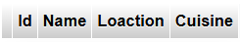
2.Create a table called FoodOrder with columns: order_id, restaurant_id, user_id, and order_total. Set order_id as PRIMARY KEY, and add a FOREIGN KEY constraint on restaurant_id referencing Restaurant(id).
CREATE TABLE FoodOrder (
order_id INT PRIMARY KEY,
restaurant_id INT,
user_id INT,
order_total DECIMAL(10,2),
FOREIGN KEY (restaurant_id) REFERENCES Restaurant(id)
);
Output:
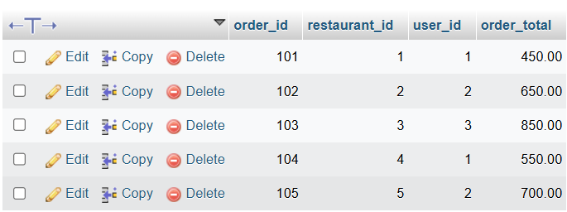

3.Insert 6 rows into a table called SpotifyUser with columns: user_id, username, email, and subscription_type. Ensure that username is UNIQUE and email is NOT NULL.<br><br><em><strong>Hint:</strong> Use the UNIQUE and NOT NULL constraints when creating the table.</em>
CREATE TABLE SpofityUser(user_id INT PRIMARY KEY AUTO_INCREMENT,username VARCHAR(100) UNIQUE,email VARCHAR(100) NOT NULL,subscription_type VARCHAR(50));
Output:
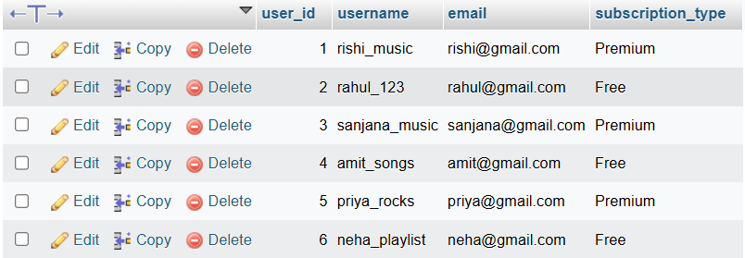

4.Create a VIEW named TopSpendersView that shows usernames and order_total from a FoodOrder table where order_total is greater than 1000.
CREATE VIEW TopSpendersView AS SELECT spofityuser.username ,foodorder.order_total FROM spofityuser JOIN foodorder on spofityuser.user_id =foodorder.order_id
WHERE foodorder.order_total > 1000;
Output:
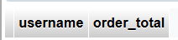

5.Write a SQL query to list all users from the TopSpendersView who have spent more than 2000, sorted by order_total
descending.<br><br><em><strong>Constraint:</strong> Only use the TopSpendersView for your query, not the original FoodOrder table.</em>
SELECT username, order_total FROM topspendersview WHERE order_total > 2000 ORDER BY order_total DESC;
Output:


